Buy New Recipes

By

Lovedeep Sharma

Level-6

Final Project

Table of Contents

Project Proposal 3

Goals and Objectives 3

Project Scope 3

Project Specifications 3

Target Audience 3

Project Deliverables 4

Resource Requirements 4

Project Tasks and Milestones 4

Project Assumptions 5

Project Report 5

Detail Design 6

Home Page 6

Registration Page 6

Login Page 7

All Recipes Admin View 7

Customer Page Admin View 8

Payment Page Admin View 8

All Recipes Customer View 9

Details Page Customer View 9

Project Testing 10

User Manual 10

Summary 10

System Configuration 10

User Access Levels 10

# 

# Project Proposal

## Goals and Objectives

The main goal or aim of the project is to implement an online web application named “Buy Recipes Online”. The main purpose of the application is help people to find recipes of their choice on their fingertips. In this application there are two types of users- admin and normal customer. Admin has different functionalities as compare to customers. Admin can add, edit, delete and check details of recipes. Admin can edit, delete and check details of the customers. Also, admin can delete and access details of the payments made by the customers.

## Project Scope

The scope of this project is to implement an app named “Buy Recipes Online” with the help of which user can find any recipe and buy it on their fingertips. The duration of the project is 20 working days which is equals to 4 weeks.

## Project Specifications

* Admin login/logout
* Add, edit, delete and check details of recipes by admin.
* Admin can delete, edit and check details of the customers.
* Admin can delete and check details of the payments.
* Admin can register new admins.
* Customer can login/logout.
* New customer can register.
* Customer can check the details of recipes and buy recipes.

## Target Audience

The target audience for this project is the food lover people who would like to try something new every day. The age can go from 18 plus to 100 plus.

## Project Deliverables

The deliverables of the project are:

|  |  |
| --- | --- |
| **Deliverable** | **Description** |
| Final Report | This will be the final report of the project. |
| Coding | The executable code of the project will go under this. |
| Documentation | This portrays the documentation of the project. |
| Testing | All the test details will be covered in this part. |

## Resource Requirements

* Windows Operating System.
* Microsoft word for documentation.
* Asp.net MVC Framework
* 64-bit Processor and 4 GB or more RAM
* Identity framework- ASP

## Project Tasks and Milestones

|  |  |  |  |  |
| --- | --- | --- | --- | --- |
| **Tasks** | **Week-1** | **Week-2** | **Week-3** | **Week-4** |
| Brainstorming and analysis |  |  |  |  |
| Planning and initial meeting Project Proposal document. |  |  |  |  |
| Database Design and UI Design |  |  |  |  |
| Identity framework implementation |  |  |  |  |
| Coding for admin and reporter |  |  |  |  |
| Testing |  |  |  |  |
| Final Documentation and closing |  |  |  |  |

## Project Assumptions

Following are the assumption made while implementing the project:

* One admin and customer will be registered by default.
* Application will be free and open source.

# Project Report

#### Functional and Non-Functional

|  |  |
| --- | --- |
| Users | Functional |
| Admin | * Login/logout * Register new admins * Admin can add, edit, delete, check details for recipes. * Admin can edit, delete and check details for customers. * Admin can delete and check details for the payments. |
| Customer | * Can view details of recipes. * Can buy recipes * New customers can register for free. * Login using valid credentials |
|  | Non- Functional |
|  | * High speed * Fast Loading time * High performance and security * All browsers compatibility. |

## Detail Design

### Home Page

The main landing page of the application. On navigation bar options are- home, All recipes, Customer Signup, Login, Register a Admin. A button named see all recipes is also present in the header images, which when click shows all the recipes available.



### Registration Page

With the help of this page, new customers can sign up for the app

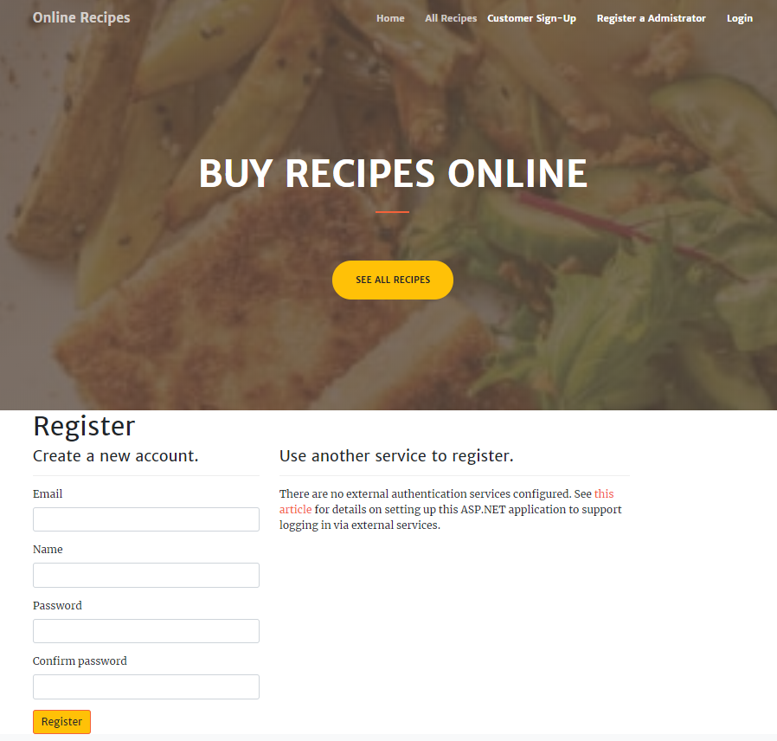

### Login Page

With the help of this page, customer and admin can login to the application using their valid credentials.

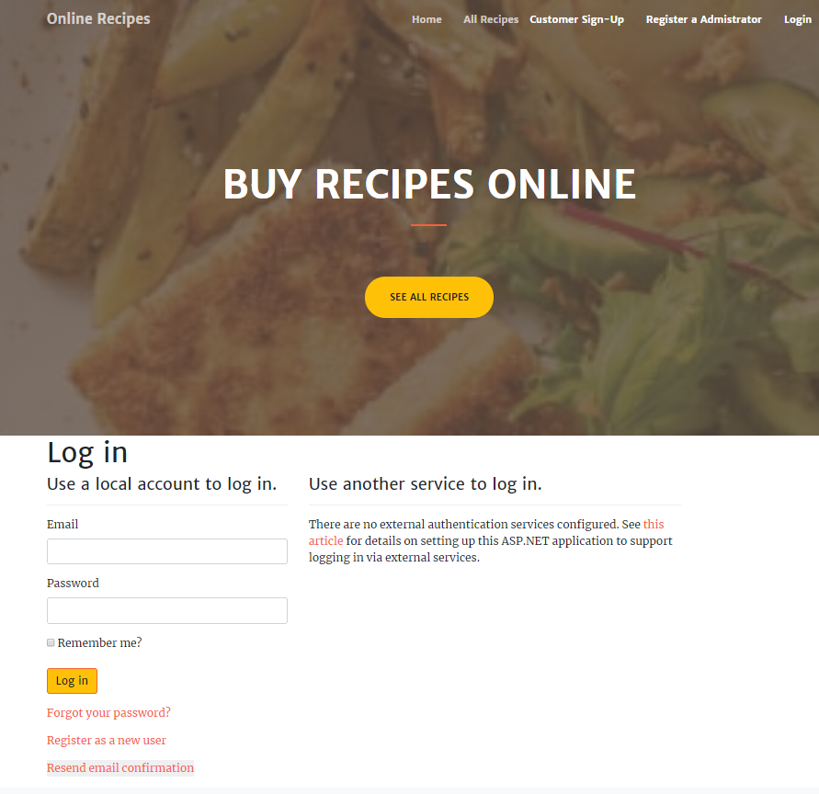

### All Recipes Admin View

This page highlights all the recipes available on the application. Admin can add new recipes, edit, delete and check details of the existing ones.

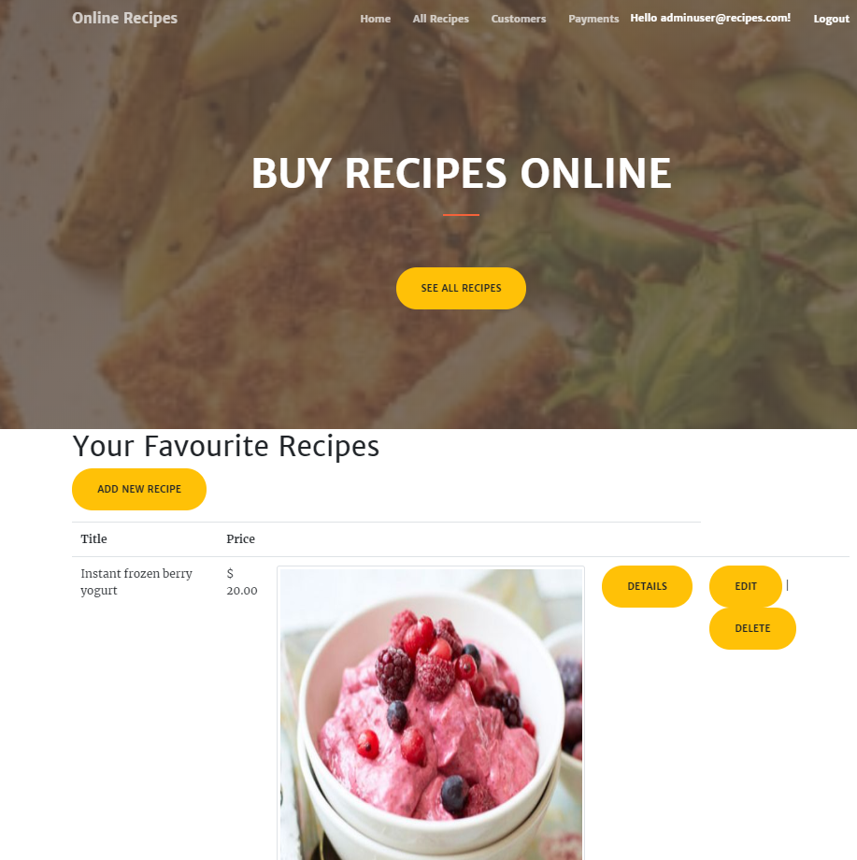

### Customer Page Admin View

With the help of this page admin can manage the customers by editing, deleting and checking their details.

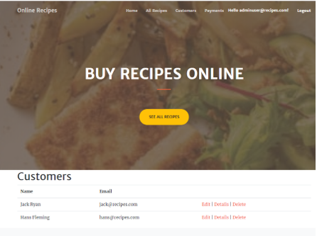

### Payment Page Admin View

With the help of this page admin can manage the payments such as delete and access details.

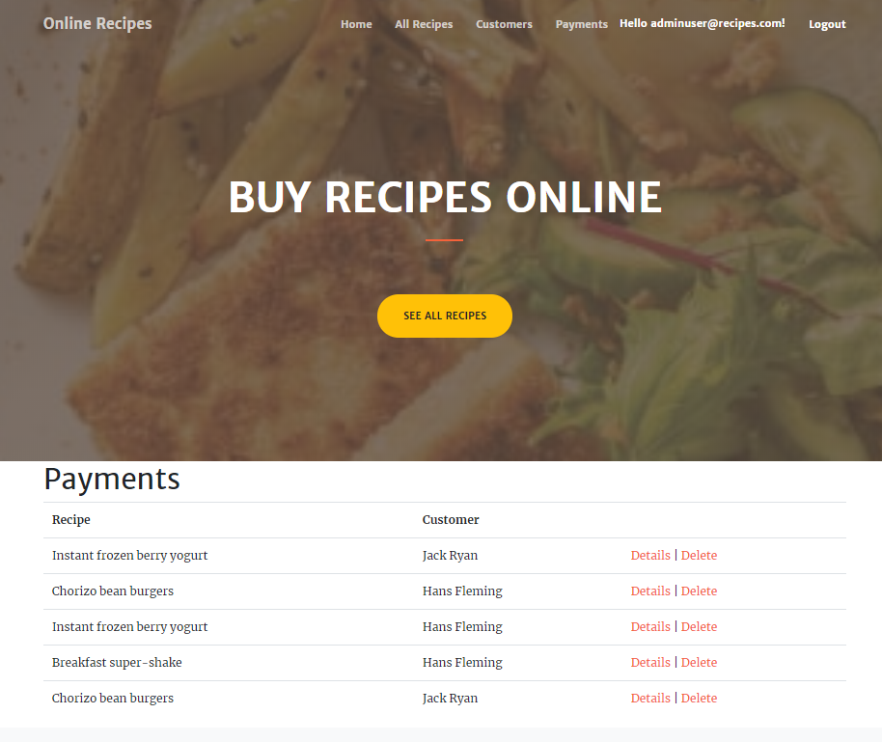

### All Recipes Customer View

With the help of this page customer can check the details of the recipes and can buy recipe of their choice.

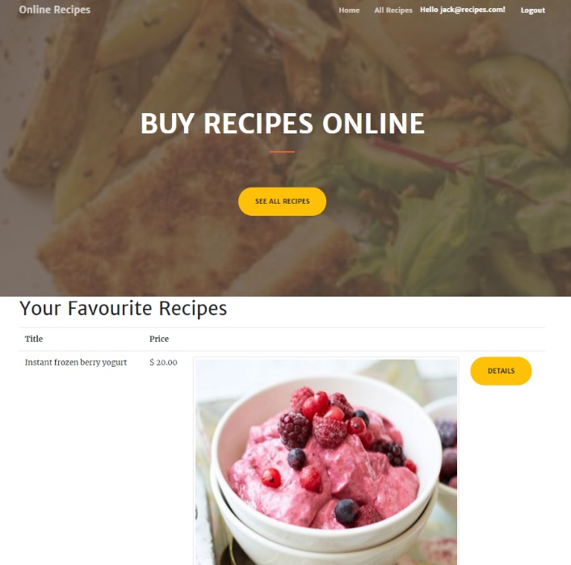

### Details Page Customer View

This page shows the details and pricing of the recipes.

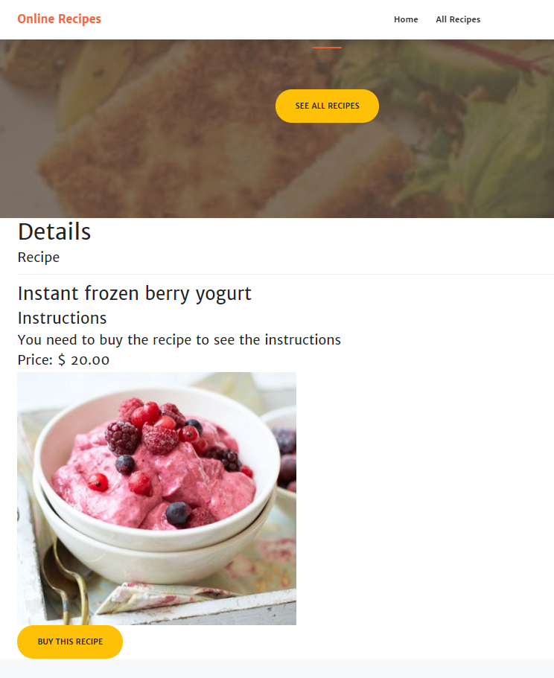

## Project Testing

The testing file for usability testing is attached as [usability test.xlsx](usability%20test.xlsx)

# User Manual

The main purpose of the application Buy recipe is to help people to find recipes of their choice on their fingertips. In this application there are two types of users- admin and normal customer. Admin has different functionalities as compare to customers. Admin can add, edit, delete and check details of recipes. Admin can edit, delete and check details of the customers. Also, admin can delete, and access details of the payments made by the customers.

## Summary

### System Configuration

This app will be useful to search new recipes.

### User Access Levels

Only registered users can access the features of this application.

* **Admin:** Admin has full access of the app can register new admins.
* **Customers:** New customers can register and existing can login using their own credentials. They have limited access.